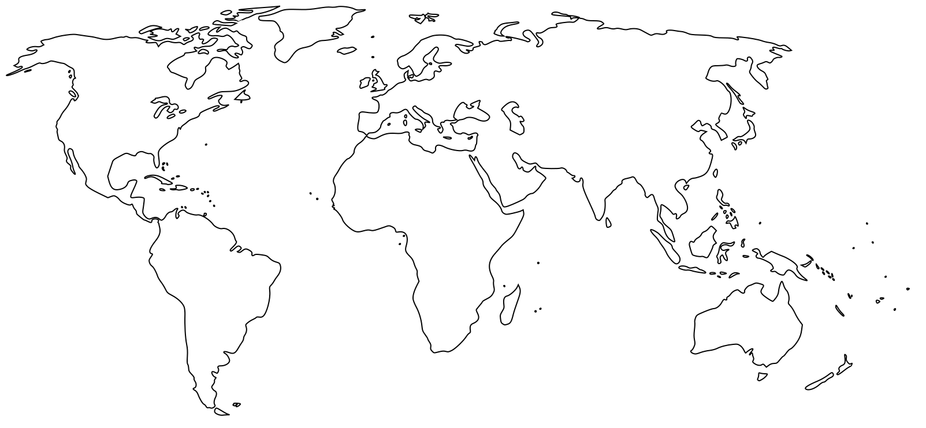

**Locate and label three trade routes:** Trans-Saharan Trade Route, Indian Ocean Trade, Silk Road Trade

**Locate and label:** Portuguese Voyages sponsored by Prince Henry

**Label the following:** Song, Yuan, Ming, Delhi Sultanate, Suljuks, Mamluks, Ottomans, Dar al Islam,

Mansa Musa, Mali, Ethiopia, Hausa, Great Zimbabwe, Swahili Coast, Khmer, Srivijaya, Gujarat, Vijayanayara, Sinhalese Monarchy, Mesa Verde, Chaco, Cahokia, Maya, Inca, Rus, Kingdom of France, Byzantine Empire

**Label the following:** London, Paris, Cordoba, Venice, Kiev, Novgorod, Beijing, Hangzhou, Baghdad, Constanintinople, Delhi, Cusco, Tenochtitlan, Timbuktu, Cairo