# **Fall of the Western Roman Empire**

by [Donald L. Wasson](https://www.worldhistory.org/user/DWasson/) published on 12 April 2018 (modified)

To many historians, the [fall of the Western Roman Empire](https://www.worldhistory.org/article/835/fall-of-the-western-roman-empire/) in the 5th century CE has always been viewed as the end of the ancient world and the onset of the Middle Ages, often improperly called the Dark Ages, despite [Petrarch](https://www.worldhistory.org/Petrarch/)'s assertion. Since much of the west had already fallen by the middle of the 5th century CE, when a writer speaks of the fall of the [empire](https://www.worldhistory.org/empire/), he or she generally refers to the fall of the [city](https://www.worldhistory.org/city/) of [Rome](https://www.worldhistory.org/Rome/). Although historians generally agree on the year of the fall, 476 CE, and its consequences for western [civilization](https://www.worldhistory.org/civilization/), they often disagree on its causes. English historian Edward Gibbon, who wrote in the late 18th century CE, points to the rise of [Christianity](https://www.worldhistory.org/christianity/) and its effect on the [Roman](https://www.worldhistory.org/disambiguation/Roman/) [psyche](https://www.worldhistory.org/Psyche/) while others believe the decline and fall were due, in part, to the influx of 'barbarians' from the north and west.

Whatever the cause, whether it was [religion](https://www.worldhistory.org/religion/), external attack, or the internal decay of the city itself, the debate continues to the present day; however, one significant point must be established before a discussion of the roots of the fall can continue: the decline and fall were only in the west. The eastern half - that which would eventually be called the [Byzantine Empire](https://www.worldhistory.org/Byzantine_Empire/) - would continue for several centuries, and, in many ways, it retained a unique Roman identity.

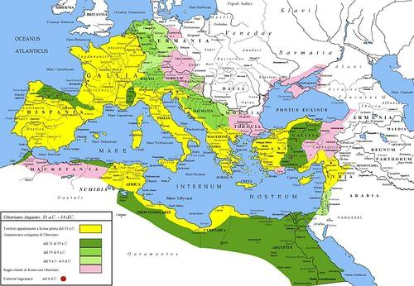

[Roman Empire under Augustus](https://www.worldhistory.org/image/4334/roman-empire-under-augustus/)

[Cristiano64 (CC BY-SA)](https://www.worldhistory.org/image/4334/roman-empire-under-augustus/)

### **A Divided Empire**

By the 3rd century CE, the city of Rome was no longer the center of the empire - an empire that extended from the British Isles to the Tigris and Euphrates Rivers and into Africa. This massive size presented a problem and called for a quick solution, and it came with the reign of Emperor [Diocletian](https://www.worldhistory.org/Diocletian/). The empire was divided into two with one capital remaining at Rome and another in the Eastern Empire at Nicomedia; the eastern capital would later be moved to Constantinople, old [Byzantium](https://www.worldhistory.org/Byzantium/), by Emperor [Constantine](https://www.worldhistory.org/disambiguation/Constantine/). The Senate, long-serving in an advisory capacity to the emperor, would be mostly ignored; instead, the power centered on a strong military. Some emperors would never step foot in Rome. In time Constantinople, Nova [Roma](https://www.worldhistory.org/Rome/) or New Rome, would become the economic and cultural center that had once been Rome.

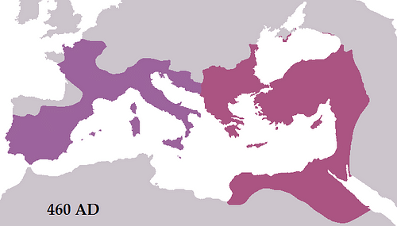

[Byzantine Empire c. 460 CE](https://www.worldhistory.org/image/7704/byzantine-empire-c-460-ce/)

[Tataryn77 (CC BY-SA)](https://www.worldhistory.org/image/7704/byzantine-empire-c-460-ce/)

Despite the renewed strength that the division provided (the empire would be divided and united several times), the empire remained vulnerable to attack, especially on the Danube-Rhine border to the north. The presence of barbarians along the northern border of the empire was nothing new and had existed for years - the army had met with them on and off since the time of [Julius Caesar](https://www.worldhistory.org/Julius_Caesar/). Some emperors had tried to buy them off, while others invited them to settle on Roman land and even join the army. However, many of these new settlers never truly became Roman even after citizenship was granted, retaining much of their old culture.

ROMAN VULNERABILITY BECAME MORE OBVIOUS AS A SIGNIFICANT NUMBER OF GERMANIC TRIBES, THE GOTHS, GATHERED ALONG THE NORTHERN BORDER.

This vulnerability became more obvious as a significant number of Germanic tribes, the Goths, gathered along the northern border. They did not want to invade; they wanted to be part of the empire, not its conqueror. The empire's great wealth was a draw to this diverse population. They sought a better life, and despite their numbers, they appeared to be no immediate threat, at first. However, as Rome failed to act to their requests, tensions grew. This anxiety on the part of the Goths was due to a new menace further to the east, the [Huns](https://www.worldhistory.org/Huns/).