SOUTH AND SOUTHEAST ASIA MAP

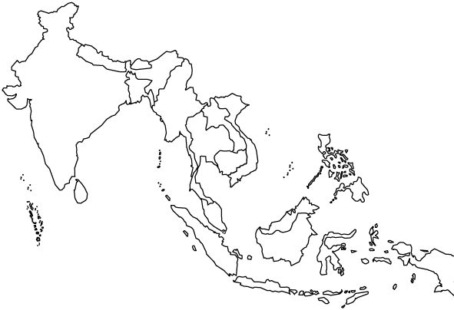

DOCUMENT ANALYSIS

| **Source:** Angkor Wat from the Khmer Kingdom. | Explain how the various belief systems and practices of South and Southeast Asia affected society over time. |
| --- | --- |

| Delhi Sultanate was a theocratic state and the administration was based on the principles of Islam. The Ulema and orthodox Muslims held a privileged position in the sultanate and they affected the policies of the Sultan. The majority of Hindus were not granted any favour by the Muslim rulers, hence they never cooperated with them.  The religious intolerance of the Sultans of Delhi also annoyed the majority of Hindus. Their act of demolishing Hindus temples and breaking idols of their gods and goddesses annoyed them all the more. Imposition of Jaziya and pilgrimage tax injured the tender feelings of the Hindus and their conversion on the points of sword offended them so much that they opposed the Sultanate and contributed to sit downfall. | Explain how and why various states of South and Southeast Asia developed and maintained power over time. |
| --- | --- |

| The **Srivijaya Empire** controlled two major passageways between India and China: the Sunda Straits from the city of Palembang and the Strait of Malacca. This control strengthened trade routes to China, India, and even Arabia. Some of the goods the people in the empire traded included ivory, tin, nutmeg, sandalwood, and strong-smelling camphor and aloes that were used for medicinal purposes. The empire had access to the trade network of spices from India and goods like silk and porcelain from China.  Even though we don’t have much political evidence about the scope of the Srivijaya Empire, records of trade between the Srivijayans and the Chinese make it clear that Srivijaya was a key economic actor. Chinese records show evidence of Srivijayan trade expeditions to the Song dynasty as well as China’s acceptance of the Srivijaya Empire as a vassal. **Vassal** states are subordinate to another nation. As a vassal to China, Srivijaya acted as a mediator between China and other smaller states on the Malay Archipelago. China considered it a great honor to bestow vassal status on another empire, so we know that the economic relationship between the two regions was strong. | Explain how and why various states of South and Southeast Asia developed and maintained power over time. |
| --- | --- |

| The term ‘Bhakthi’ refers to ‘devotion’. As a movement, it emphasized on the **mutual intense emotional attachment** and **love of a devotee toward a personal god and of the god for the devotee.** This movement originated in South India in the 7th and 10th CE, mostly in the poems**.** These poems were composed in Tamil; the poems were addressed to Lord Vishnu and Lord Shiva respectively.  Bhakti soon spread to North India, appearing most notably in the **10th-century Sanskrit text the Bhagavata-Purana**. It swept over east and north India from the 15th century onwards, reached its peak between the 15th and 17th century CE. The Bhakti Saints moved against the austerities propagated by the Buddhist and Jain schools and professed that ultimate devotion to god was the means to salvation.  **Reasons behind the movement**  The movement started as a response to the evil practices that had crept into Hinduism. Some of the other reasons which fuelled the spread of the movement across the country were:   1. The spread of Islam 2. Emergence of great reformers 3. Influence of Sufi sects of Islam 4. Influence of Vaishnavism and Shaivism (Hindu) ideologies | Explain how the various belief systems and practices of South and Southeast Asia affected society over time. |
| --- | --- |